34.13: a)

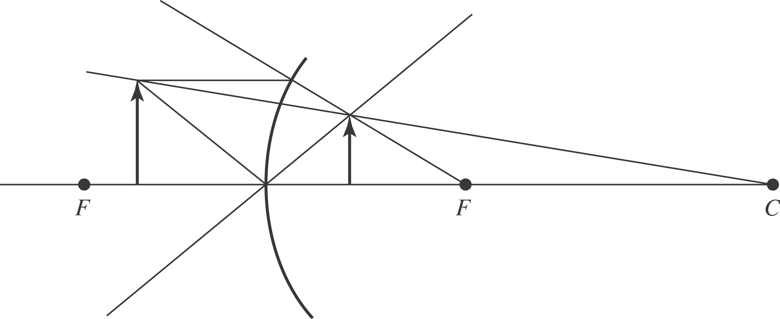

b) 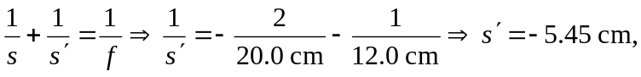to the right of the mirror.
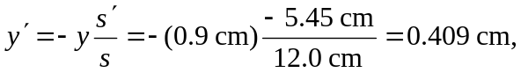and the image is upright and virtual.

